# **Project - Association Rule Minig**

# Business Intelligence and Analytics

*A step by step procedure of analysing dataset in SAS Miner*

1. Create a Data Source choosing BANK table in the data source library.

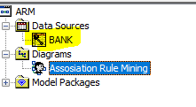

1. Change the meta data variables:

ACCOUNT: ID

SERVICE: Target

VISIT: Sequence

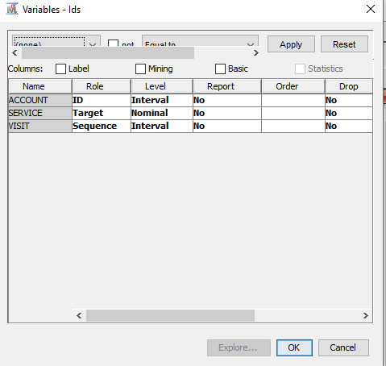

1. Select Transaction for the value of the Role field
2. Click okay and then drag the BANK data source to the Analysis Diagram.
3. Click the Explore tab and drag Association tool into the diagram and connect I to the BANK data source.



1. Click on the Association and explore the property panel on the left side.

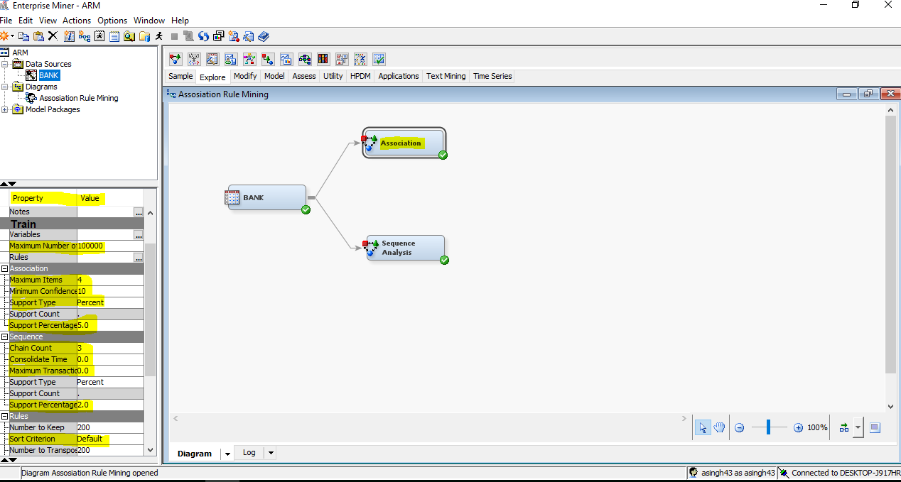

1. The Export Rule by ID property determines whether the **Rule-by-ID** data is exported from the node and whether the Rule Description table is available for display in the Results window. Set the value for Export Rule by ID to **Yes**.

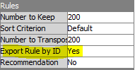

1. Other options in the Properties panel would be –

* Minimum confidence level – it is the confidence level to generate a rule and by default it is 10%.
* Support Type – It help us to choose whether we should go with the Support Count or Support Percentage and by default it is Percentage.
* Maximum Items – It defines the maximum number of item set to be considered.

1. Access the variable dialog box for the Association Rule from the property panel on the left side under the **Train** Property.

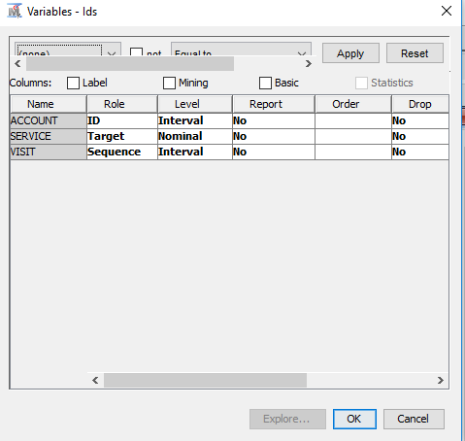

1. Select **NO** for the VISIT variable if it is Yes in your variable dialogue box.

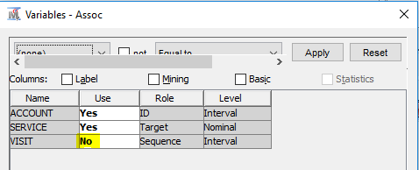

1. Run the diagram from the Association node and view the Result.

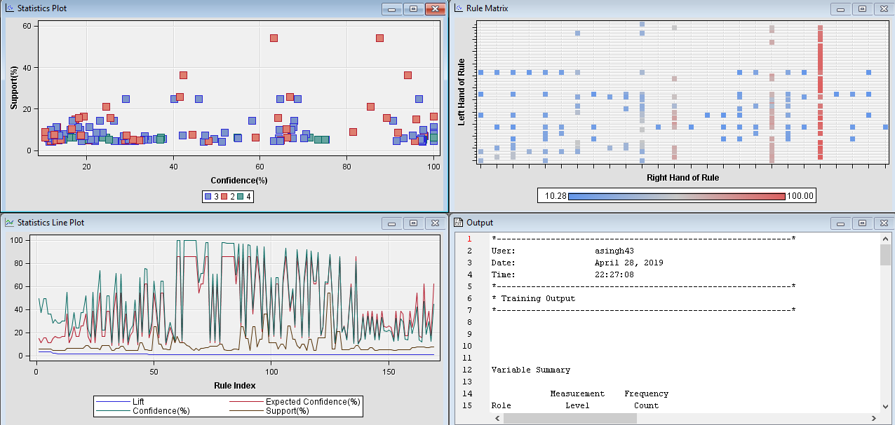

We can see the Statistics Plot, Statistic Line Plot, Rule Matrix and Output windows visible.

1. Maximize the Statistics Line Plot window.

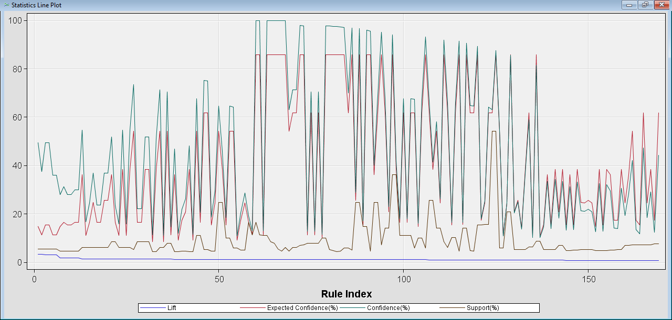

This graph line plot graphs the lift, expected confidence, confidence and support for each of the rules by rule index number.

We can see that the rule are ordered in the in descending order to the lift.

1. To view the description of the rules, select the View🡪Rules🡪Rule Description.

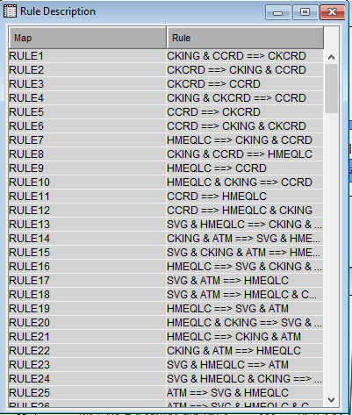

* The highest rule is checking and credit card implies check card.
* There is symmetry between rule 1 and rule 2 because lift is symmetric.
* One of the major lift rules is that a home equity line of credit (LOC) implies checking and check card. We can analyze it that customer who do not already have a checking account, should be offered a checking and check card with a special promotion.

1. Examine the rule matrix.

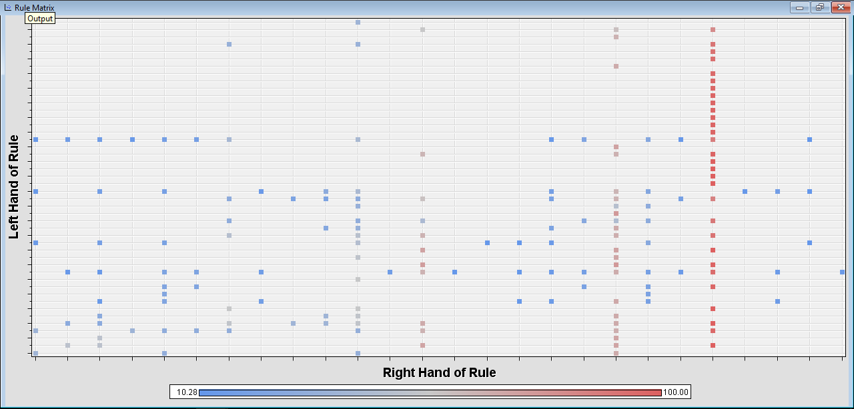

The points are colored, based on the confidence of the rules. For example, the rule with the highest confidence are in the column in the above picture.

1. Close the Result window.

**SEQUENCE ANALYSIS**

1. Add the Association node and connect it to the BANK data source and rename that node as Sequential Analysis.

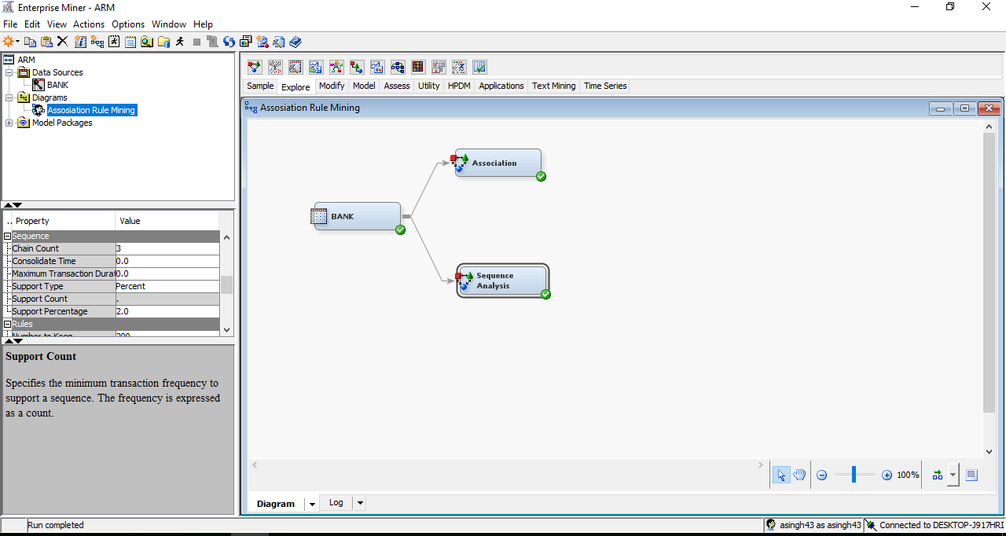

1. All the variable have the Use value equals to Yes.

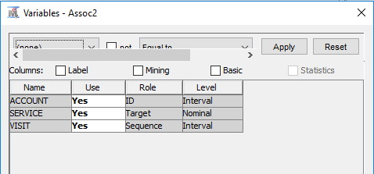

1. Set the export Rule by Id to Yes.

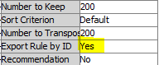

1. Examine the Sequence Section under the Properties panel.

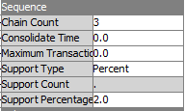

1. Run the Diagram for Sequential Analysis.

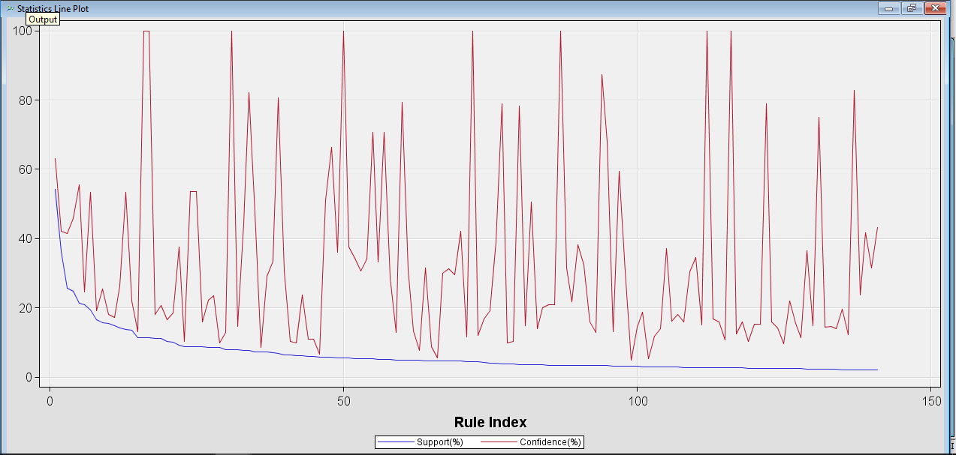

The statistics line plot graphs the confidence and support for each of the rule by the rule index number.

1. Select View🡪Rules🡪Rule description to view the description of the data.

